f
More information at cph12.dk
SPEAKERAFTEN 6. november 2021 VESTERBRO BIBLIOTEK OG KULTURHUS Lyrskovgade 4, 3. sal, 1758 København VHele pakken på én aften: FÆLLESSKAB, BEDRING & SERVICE Lyt til speaks og stil spørgsmålKom og spis dejlig mad og hyg med andre AAereÅbent for ALLE
INTERNATIONAL
AA CONVENTION 2022
6th, 7th, 8th of May
At Vesterbro Kulturhus, Lyrskovgade 4, 1758 V

In the start of May Cph12 invites you to a weekend with AA
Experience speaks, the 12 steps, meditation, fun and games and much more
There will be lots of networking with the people of AA plus hygge and food
Saturday night we will PARTY!
Friday,  6th of May 2022 | Main Room | Room Bill (ACA) | Room Bob  (Al Anon)
17.00 | Venue opens  Set-up of rooms | Newcomer meeting  Speak: Flemming F
17.30 |  |  | Traditions
18.00 | Speak: Kevin H (US)
18.40 | Q&A
19.00 | Countdown  Networking and hygge
20.00 | Speak: Chris (ZA)
20.40 | Q&A
21.00 | Hygge and music | Newcomer meeting  Speak: Betina
22.00 | Thank you for today
Lunch (Friday night too)
Make your own sandwich with homemade filling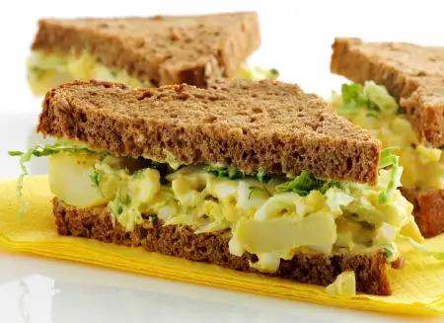
Dinner Menu Saturday
Butterchicken with rice
(Vegan/vegetarian too)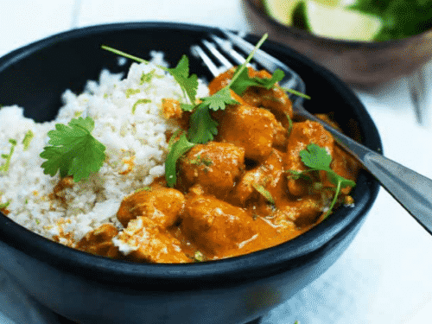

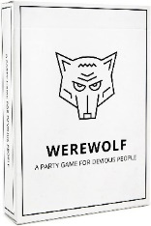
7th
Tradition
Saturday,  7th of May 2022 | Main Room | Room Bill | Room Bob
10.00 | Coffee, tea and networking | Topic: Emotional sobriety  Introduction: Peter Å | Traditions
11.00 | Speak:  Mia-Nelle D
12.00 | Coffee and tea | Surprise | Couples in recovery
13.00 | Lunch
14.00 | Petanque  Soccer  Elephant Walk  Baseball | Film: My Name is Bill W | Werewolf
16.00 | Workshop  Facilitator: Kevin (US)
17.00 | Speak: Rosa T
18.30 | Dinner
19.15 |  | The solution of becoming your own loving parent, recovery tools and techniques  Introduction: Victor D
20.00 | Speak: Kaj H
20.40 | Q&A
21.00 | Break
21.30  The night finishes around midnight | Entertainment  Fireshow  Music and dancing
Sunday,  8th of May 2022 | Main Room | Room Bill | Room Bob
10.00 | Coffee, tea and networking |  | Al-Anon plus AA on childrens terms
11.00 | Speak: John (UK)
11.40 | Q&A
12.00 | Workshop  Q&A - discussion  Facilitator: John (UK)
13.00 | Lunch | Newcomer meeting  Speak: Brian N
14.00 | Countup  Serenity prayer
15.00 | Cleaning
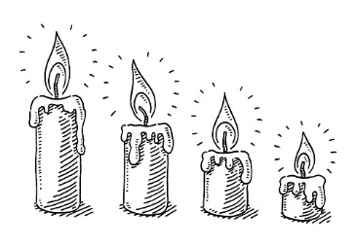
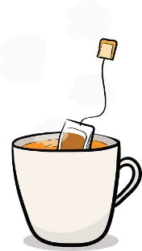
Countdown - Countup

